Types of Services
ClusterIP − This helps in restricting the service within the cluster. It exposes the service within the defined Kubernetes cluster.
spec:
type: NodePort
ports:
- port: 8080
nodePort: 31999
name: NodeportService
NodePort − It will expose the service on a static port on the deployed node. A ClusterIP service, to which NodePort service will route, is automatically created. The service can be accessed from outside the cluster using the NodeIP:nodePort.
spec:
ports:
- port: 8080
nodePort: 31999
name: NodeportService
clusterIP: 10.20.30.40
Load Balancer − It uses cloud providers’ load balancer. NodePort and ClusterIP services are created automatically to which the external load balancer will route.
A full service yaml file with service type as Node Port. Try to create one yourself.
apiVersion: v1
kind: Service
metadata:
name: appname
labels:
k8s-app: appname
spec:
type: NodePort
ports:
- port: 8080
nodePort: 31999
name: omninginx
selector:
k8s-app: appname
component: nginx
env: env_name

What is Ingress
Kubernetes ingress is a collection of routing rules that govern how external users access services running in a Kubernetes cluster. However, in real-world Kubernetes deployments, there are frequently additional considerations beyond routing for managing ingress.
Ingress exposes HTTP and HTTPS routes from outside the cluster to services within the cluster. Traffic routing is controlled by rules defined on the Ingress resource.
Here is a simple example where an Ingress sends all its traffic to one Service:
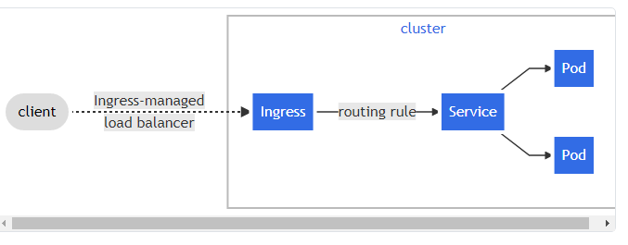
An Ingress may be configured to give Services externally-reachable URLs, load balance traffic, terminate SSL / TLS, and offer name-based virtual hosting. An Ingress controller is responsible for fulfilling the Ingress, usually with a load balancer, though it may also configure your edge router or additional frontends to help handle the traffic.
An Ingress does not expose arbitrary ports or protocols. Exposing services other than HTTP and HTTPS to the internet typically uses a service of type Service.Type=NodePort or Service.Type=LoadBalancer.
In Kubernetes, there are three general approaches to exposing your application.
- Using a Kubernetes service of type NodePort, which exposes the application on a port across each of your nodes
- Use a Kubernetes service of type LoadBalancer, which creates an external load balancer that points to a Kubernetes service in your cluster
- Use a Kubernetes Ingress Resource
An Ingress provides the following:
- Externally reachable URLs for applications deployed in Kubernetes clusters
- Name-based virtual host and URI-based routing support
- Load balancing rules and traffic, as well as SSL termination

What is the Ingress Controller?
If Kubernetes Ingress is the API object that provides routing rules to manage external access to services, Ingress Controller is the actual implementation of the Ingress API. The Ingress Controller is usually a load balancer for routing external traffic to your Kubernetes cluster and is responsible for L4-L7 Network Services.
Layer 4 (L4) refers to the connection level of the OSI network stack—external connections load-balanced in a round-robin manner across pods. Layer 7 (L7) refers to the application level of the OSI stack—external connections load-balanced across pods, based on requests. Layer 7 is often preferred, but you should select an Ingress Controller that meets your load balancing and routing requirements.
Ingress Controller is responsible for reading the Ingress Resource information and processing that data accordingly. The following is a sample Ingress Resource:
As an analogy, if Kubernetes Ingress is a computer, then Ingress Controller is a programmer using the computer and taking action. Furthermore, Ingress Rules act as the manager who directs the programmer to do the work using the computer. Ingress Rules are a set of rules for processing inbound HTTP traffic. An Ingress with no rules sends all traffic to a single default backend service.
Looking deeper, the Ingress Controller is an application that runs in a Kubernetes cluster and configures an HTTP load balancer according to Ingress Resources. The load balancer can be a software load balancer running in the cluster or a hardware or cloud load balancer running externally. Different load balancers require different Ingress Controller implementations.
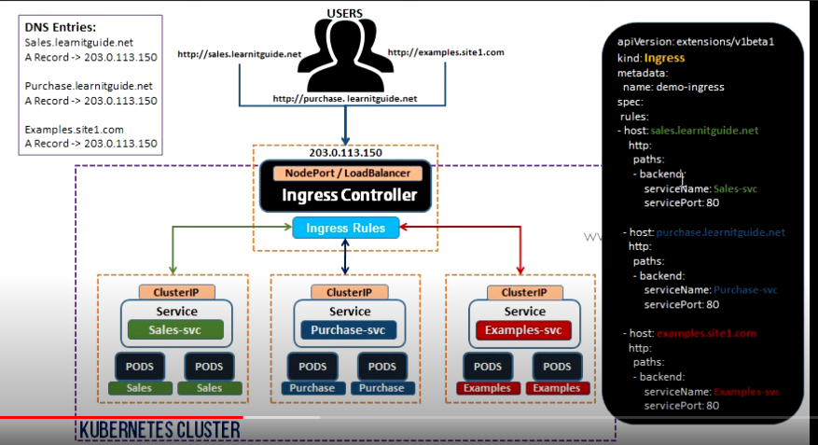

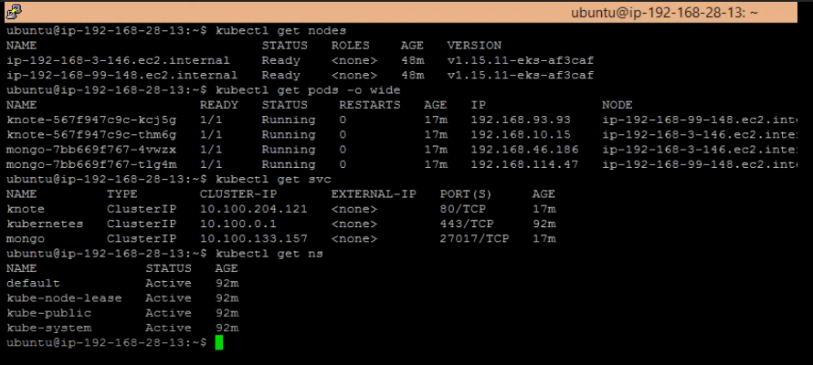

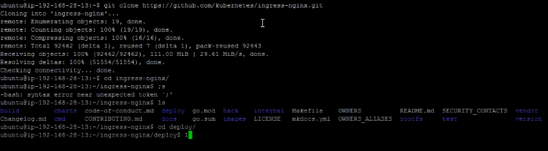

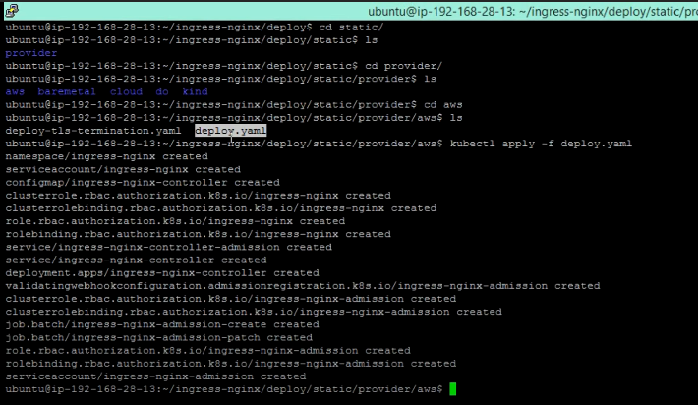

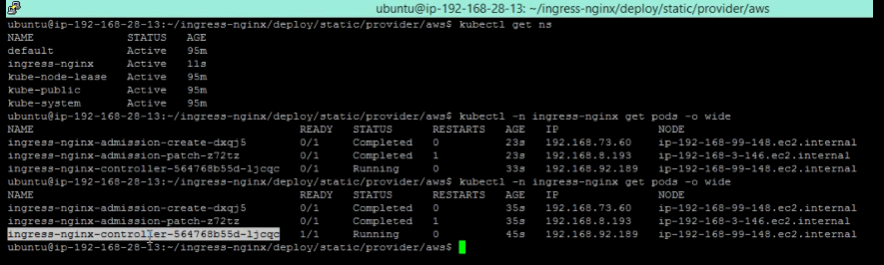

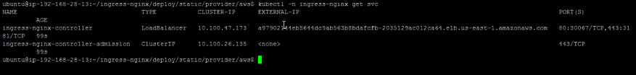

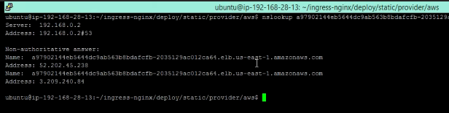

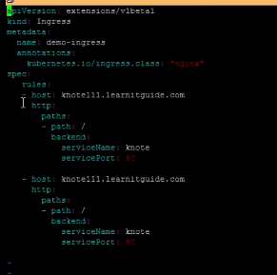

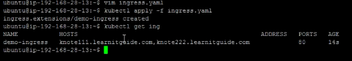

Ingress vs. ClusterIP vs. NodePort vs. LoadBalancer
Ingress, ClusterIP, NodePort, and LoadBalancer are all ways to get external traffic into your cluster, and they each do it differently. Let’s take a look at how each works and where you would use them.

ClusterIP
ClusterIP is the preferred option for internal service access and uses an internal IP address to access the service. Some examples of where ClusterIP might be the best option include service debugging during development and testing, internal traffic, and dashboards.
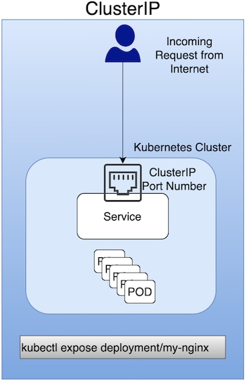

NodePort
A NodePort is a virtual machine (VM) used to expose a service on a Static Port number. It's primarily used for exposing services in a non-production environment (in fact, production use is not recommended). As an example, a NodePort would be used to expose a single service (with no load-balancing requirements for multiple services).
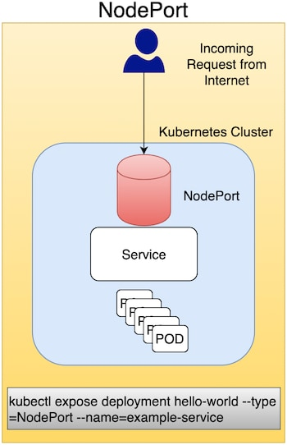

LoadBalancer
This method uses an external LoadBalancer to expose services to the Internet. You can use LoadBalancer in a production environment, but Ingress is often preferred.
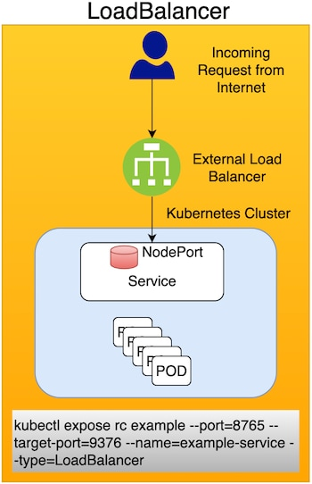

Ingress
Ingress enables you to consolidate the traffic-routing rules into a single resource and runs as part of a Kubernetes cluster. Some reasons Kubernetes Ingress is the preferred option for exposing a service in a production environment include the following:
- Traffic routing is controlled by rules defined on the Ingress Resource.
- Ingress is part of the Kubernetes cluster and runs as pods.
- An external Load Balancer is expensive, and you need to manage this outside the Kubernetes cluster. Kubernetes Ingress is managed from inside the cluster.
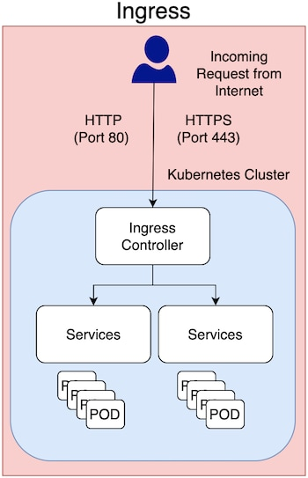
In production environments, you typically use Ingress to expose applications to the Internet. An application is accessed from the Internet via Port 80 (HTTP) or Port 443 (HTTPS), and Ingress is an object that allows access to your Kubernetes services from outside the Kubernetes cluster.

